23.88: a) 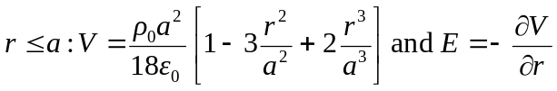
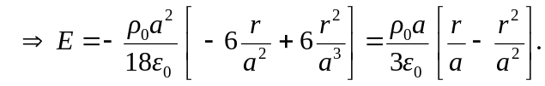
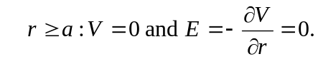
b) 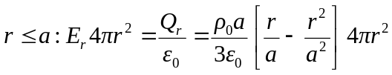
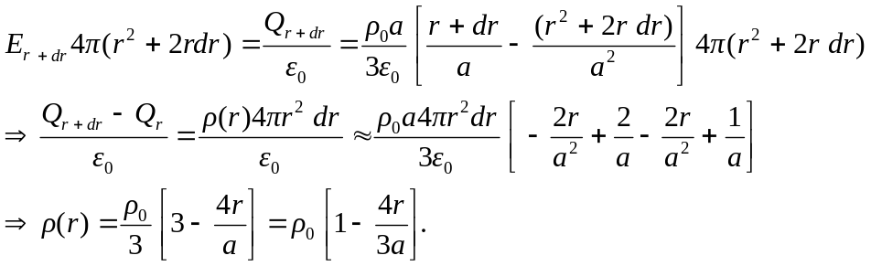

c) 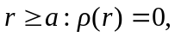 so the total charge enclosed will be given by:
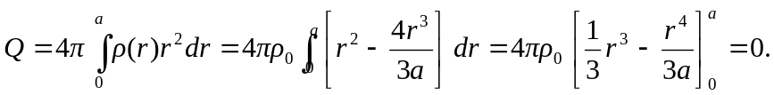
Therefore, by Gauss’s Law, the electric field must equal zero for any position 